--------------------------------------------------------------------------------------------------------------------------
NAME: ROGHAN B
REG.NO: 192419006
COURSE CODE: ECA0905
COURSE NAME: DIGITAL SIGNAL PROCESSING
PRACTICAL LAB RESULTS
--------------------------------------------------------------------------------------------------------------------------
EXP: 1.1:
CODE:
clc; clear; close all;
Fs = 10000;
Fp = 1000;
Fst = 1500;
Rp = 1;
Rs = 60;
Wp = Fp/(Fs/2);
Ws = Fst/(Fs/2);
[N,Wn] = buttord(Wp,Ws,Rp,Rs);
fprintf('Minimum Filter Order (N) = %d\n',N);
fprintf('Cutoff Frequency (Wn) = %.4f\n',Wn);
[b,a] = butter(N,Wn,'low');
figure;
freqz(b,a,1024,Fs);
title('Magnitude and Phase Response - LPF');
figure;
[h,n] = impz(b,a,50);
stem(n,h,'filled'); grid on;
title('Impulse Response'); xlabel('n'); ylabel('Amplitude');
figure;
stepz(b,a,50);
title('Step Response');
figure;
grpdelay(b,a,1024,Fs);
title('Group Delay');
figure;
zplane(b,a);
title('Pole-Zero Plot - LPF');
t = 0:1/Fs:0.05;
x = sin(2*pi*500*t) + sin(2*pi*3000*t); % 500 Hz (pass) + 3000 Hz (reject)
y = filter(b,a,x);
figure;
subplot(2,1,1); plot(t,x); grid on;
title('Input Signal'); xlabel('Time (s)'); ylabel('Amplitude');
subplot(2,1,2); plot(t,y); grid on;
title('Filtered Output Signal (Low-Pass)'); xlabel('Time (s)'); ylabel('Amplitude');
OUTPUT:
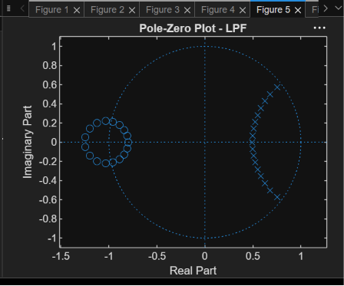
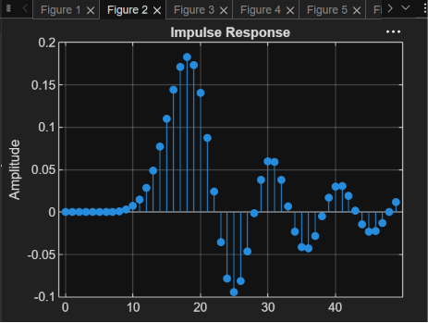
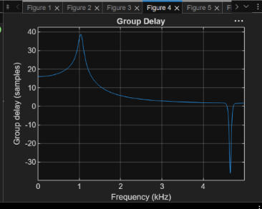
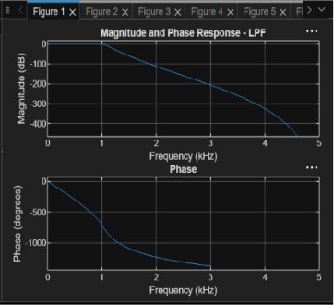
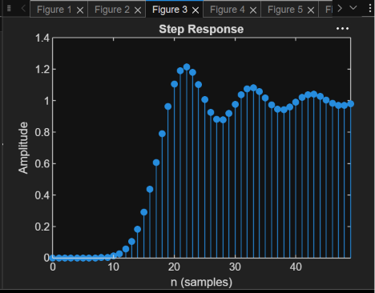

EXP: 1.2:
CODE:
clc; clear
Fs=10000; Fp=3000; Fst=2000;
[N,Wn]=buttord(Fp/(Fs/2),Fst/(Fs/2),1,60); [b,a]=butter(N,Wn,'high');
freqz(b,a)
% Impulse Response
figure
[h,n]=impz(b,a,50);
stem(n,h), grid on
title('Impulse Response')
figure
stepz(b,a)
title('Step Response')
figure
grpdelay(b,a)
title('Group Delay')
figure
zplane(b,a)
title('Pole-Zero Plot')
fprintf('Minimum Filter Order (N) = %d\n',N); fprintf('Cutoff Frequency (Wn) = %.4f\n',Wn);
OUTPUT:
